Table of Contents

Use Case 1 - The user inquiries about HSA versus CI and the agent responds with the difference. 1

Use Case 2 - An existing group insurance member inquires about critical insurance. The user is not currently enrolled in CI. The agent shares a video with information regarding CI, and asks if the user would like help selecting a CI plan. The user responds yes. The agent then asks a few questions, and displays an infographic of price. Lastly, the agent gathers contact information and the conversation ends. 2

Use Case 3 - The user asks how to submit a claim, and the agent utilizes Watson Discovery to obtain documents which have relevant answers. 6

Use Case 4 - An existing group insurance member inquires about critical insurance. The user is currently enrolled in CI. The agent then shares information about the user’s current plan. Lastly, the agent gathers contact information and the conversation ends. 7

**Reference Website:**

# Use Case 1

## Use Case 1 – The user inquiries about HSA versus CI and the agent responds with the difference.

**USER:**

I have an HSA to pay for additional medical expenses, why would I need CI?

**BOT:**



Health Savings Account FAQ

**BOT:**

Yes, you can use your HSA, but that’s money out of your pocket. Critical Illness and Accident insurance helps you offset your non-medical expenses, which you could not use your HSA funds for.

**BOT:**

What else can I help you with today?

# Use Case 2

## Use Case 2 - An existing group insurance member inquires about critical insurance. The user is not currently enrolled in CI. The agent shares a video with information regarding CI, and asks if the user would like help selecting a CI plan. The user responds yes. The agent then asks a few questions, and displays an infographic of price. Lastly, the agent gathers contact information and the conversation ends.

**BOT:**

Hi Good Morning, welcome to the Watson Employee Care Virtual Agent for IBM Employees, what can I do for you today?

**USER:**

IBM is offering critical illness and accident insurance, what is this?

**BOT:**

Please choose which type of insurance you would like to explore first...

**USER:**

*Selects Critical Illness Insurance*

**BOT:**

I can help you with this! I need a little information to get started...are you an existing group insurance member through your company?

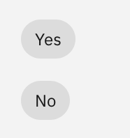

**USER:**

*Selects Yes*

**BOT:**

Great! I can look up the details. What is your companies group number?

**USER:**

123456789

(This is the exact value to be entered, we are validating in Watson)

**BOT:**

Thank you. I see that you are currently enrolled in Guardian's Health Insurance Plan.

Do you know if you are currently enrolled in a Critical Insurance plan as a part of your Group benefits?

**USER:**

No

**BOT:**

That's OK, it not to late to sign up.

Critical Illness insurance helps you cover expenses if you become seriously ill.

[Here is a video on how Critical Illness Insurance Works](https://assistant-us-south.watsonplatform.net/static/CI_Video)

**BOT:**  
Can I help you select a Critical Illness plan?

**USER:**

Yes

**BOT:**

First, we need to know your age?

**USER:**

48

(Any age can be entered)

**BOT:**

Are you married or single?

**USER:**

Married

**BOT:**

Can you tell me what the name of your health insurance company if any other than Guardian?

**USER:**

Aetna

**BOT:**

How many children do you have?

**USER:**

3

(Any number will be accepted)

**BOT:**

Do you have an active lifestyle or what is your level of Activity? Low, Moderate or High?

**USER:**

High

(The user can select low, moderate, or high)

**BOT:**

Sounds like you and your spouse have a busy, active life. Critical Illness and Accident insurance provides important financial support if you or your family become seriously ill or injured. An average time to recover is about 36 weeks, so you'll want to select coverage that can meet your family's unique financial needs.

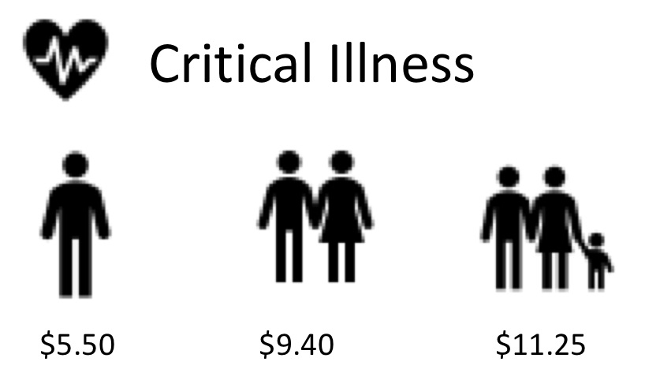

Your enrollment is almost over. I can send you a reminder. (I won't use this information for any other purpose)

Please share your email.

**USER:**

walt@ibm.com

(Any email will work)

**BOT:**

Thank you for providing your email address of walt@ibm.com, we will update our information for you.

**BOT:**

How about your phone number?

**USER:**

9125779057

(Any 10 digit number, not starting in 1, will work)

**BOT:**

We will only use 9125779057 for purposes of updating you with pertinent information.

What else can I help you with today?

**USER:**

Nothing

**BOT:**

Thanks for talking to us. Have a great day!

# Use Case 3

## Use Case 3 – The user asks how to submit a claim, and the agent utilizes Watson Discovery to obtain documents which have relevant answers.

**USER:**

**How do I contact Guardian with benefit or claim questions?**

**BOT:**

I searched my knowledge base and found this information which might be useful:

**["How do I contact Guardian with benefit or claim questions?"]**

["For claim questions or status, you have the option of calling us toll-free at 800 268 2525 or visiting Guardian’s web portal: guardiananytime.com.","If you would like to submit claim information, it can be faxed to 610 807 2999 or it can be submitted securely through guardiananytime.com.","Our regular business hours are Monday through Friday, 8:00 a.m. to 8:00 p.m. EST.","When contacting Guardian, be sure to have the individual’s name, plan number, claim number and any contact information included."]

**["How should a claim be submitted?"]**

["You should complete the Group Critical Illness claim form (GG-016218). The form may be obtained from your Human Resource department or via the website at guardiananytime.com. In addition to the completed claim form, please submit additional documentation identifying services rendered with the provider(s), patient’s name and dates, and types of treatment/services. This could include, but is not limited to, copies of the following:","Medical bills from the provider(s)","Medical records including diagnosis, progress notes, test results, admit/discharge summaries, and operative reports","Emergency room report Note: For a diagnosis of a stroke, we will need the MRS form completed by the physician and submitted 30 days post-event.","The completed claim form along with supporting documentation may be submitted via mail, fax or via the website: Mail: Guardian Life Insurance Critical Illness Claims PO Box 14334 Lexington, KY 40512 Fax: 610 807 2999 Secure E-mail: guardiananytime.com click ‘secure channel’ and select [cru@glic.com](mailto:cru@glic.com)"]

**["When should a claim be submitted?"]**

["A claim should be submitted once the covered individual has been diagnosed with a covered Critical Illness."]

# Use Case 4

## Use Case 4 - An existing group insurance member inquires about critical insurance. The user is currently enrolled in CI. The agent then shares information about the user’s current plan. Lastly, the agent gathers contact information and the conversation ends.

**BOT:**

Hi Good Morning, welcome to the Watson Employee Care Virtual Agent for IBM Employees, what can I do for you today?

**USER:**

My employer is offering critical illness and accident insurance, what is this?

**BOT:**

Please choose which type of insurance you would like to explore first...

**USER:**

*Selects Critical Illness Insurance*

**BOT:**

I can help you with this! I need a little information to get started...are you an existing group insurance member through your company?



**USER:**

*Selects Yes*

**BOT:**

Great! I can look up the details. What is your companies group number?

**USER:**

123456789

(This is the exact value to be entered, we are validating in Watson)

**BOT:**

Thank you Guardian Member.

Do you know if you are currently enrolled in a Critical Insurance plan as a part of your Group benefits?

**USER:**

Yes

**BOT:**

Great! Please enter the last four digits of your SSN so I can give you your plan specific information.

**USER:**

1234

(This is the exact value to be entered, we are validating in Watson)

**BOT:**

You are currently enrolled in Critical Illness Insurance and you are covered for $25,000 upon first diagnoses of a specified critical illness and $10,000 upon a second diagnosis - money that can be used however you deem fit.

Watson Assistant said

Your enrollment is almost over. I can send you a reminder. (I won't use this information for any other purpose)

Watson Assistant said

Please share your email.

**USER:**

walt@ibm.com

(Any email will work)

**BOT:**

Thank you for providing your email address of walt@ibm.com, we will update our information for you.

**BOT:**

How about your phone number?

**USER:**

9125779057

(Any 10 digit number, not starting in 1, will work)

**BOT:**

We will only use 9125779057 for purposes of updating you with pertinent information.

What else can I help you with today?

**USER:**

Nothing

**BOT:**

Thanks for talking to us. Have a great day!